**Probability and Statistics - IT2120**

**Lab Sheet 07**

**Name: Manthrirathna S.N**

**ID: IT24102791**

**Question 1**

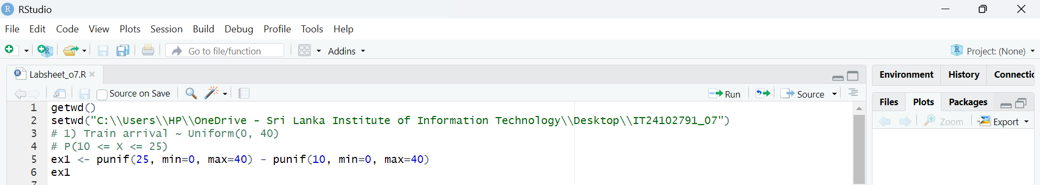

**Question 2**

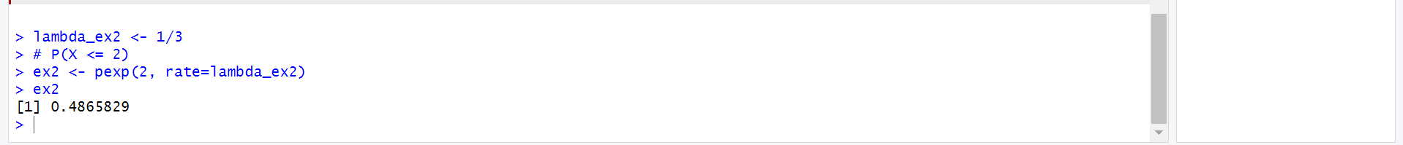

**Question 3**

